PREPARING FOR YOUR CHILD’S BAPTISM
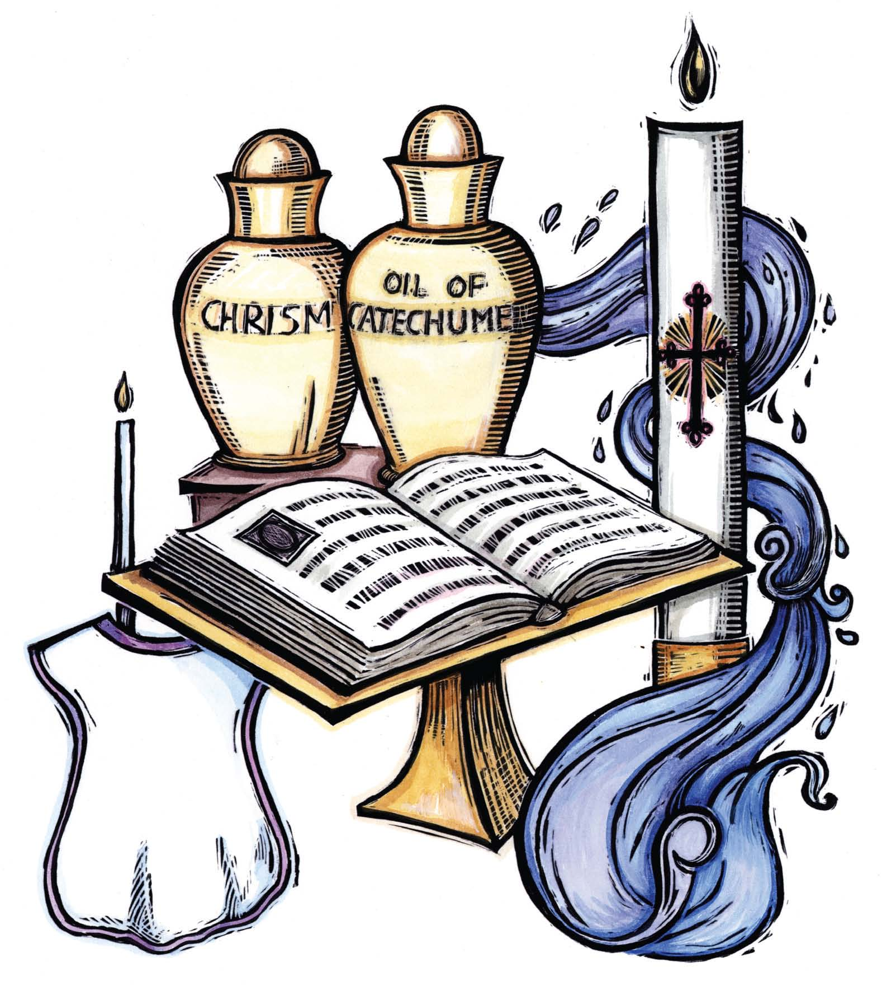

ANNUNCIATION CATHOLIC CHURCH

WASHINGTON, DC

Baptism is the first of the Sacraments of Initiation and as such it is a necessary requirement of the reception of any other Sacrament. It is through Baptism that we are reborn as children of God and incorporated into the Church of Christ thereby receiving the rights and obligations associated with that membership. Through Baptism we become shares in the priestly, prophetic, and kingly functions of Christ and we are called to exercise the mission which God has entrusted to the Church to fulfill in the world. Baptism is a time for celebration and a time for joy. It is a birth into the Christian community and is, in every way, as solemn and important as physical birth itself. The community of Annunciation Catholic Church presents this set of guidelines to help you plan and prepare for Baptism in the best possible way and with as much ease and convenience as possible.

MINISTER OF BAPTISM

The Church requires an ordained cleric (bishop, priest, or deacon) to celebrate the Sacrament of Baptism except in the case of an emergency. Normally, this is the pastor, one of the associate pastors, or one of the deacons of the parish. At times, however, it may be desired to invite another priest or deacon to minister the Baptism. Archdiocesan policy recommends that such permission be given only to a priest (or deacon) who has served in the parish before of who is a relative of the person being baptized. Permission may be given for a very personal family friend to minister the Baptism. If this is desired, Andreja Mezek should be notified well in advance and permission of the pastor obtained. In cases of emergency (imminent danger of death) anyone may administer the Sacrament of Baptism as long as they desire to do what the Church does, and the correct form of words and pouring water is observed. In this case, if the person lives, the ceremonies of Baptism must still be performed by an ordained cleric at an appropriate time, although the actual Baptism itself is not repeated.

ADULTS
Adults receive the Sacrament of Baptism after completing the Rite of Christian Initiation for Adults (RCIA). RCIA classes are for persons who may be contemplating joining the Roman Catholic Church whether they have already been baptized into another Christian Church or not. Those who are validly baptized already are not re-baptized when they are accepted into the Church; but, the period or preparation is usually the same as those who are not baptized. Adults interested in RCIA should contact the Office of Faith Formation at 202.362.3323 ext 13.

CHILDREN
In ordinary circumstances, the Baptism of children 7 years old or older is administered through the Rite of Christian Initiation of Children (RCIC). The Office of Faith Formation at Annunciation can handle this and they should be contacted at 202.362.3323 ext.13 for more information. Exceptions to the requirement are generally not available because it is part of Church law.

INFANTS
The vast majority of Baptisms performed at Annunciation involve children under the age of 7; so the remainder of this document deals exclusively with this case. The custom of baptizing children in their infancy in the Catholic Church is ancient, going back to the early days of the Church during the time of the Apostles. The Baptism of children under the age of 7 requires the consent of at least one of the parents (or guardians). It also requires a well-founded expectation that the child will be brought up in the Catholic religion. The interpretation of this requirement here at Annunciation is that at least one the parents (or guardians) should be an actively practicing Catholic.

GODPARENTS
AND CHRISTIAN WITNESSES

The role of Godparents is to help their Godchild lead a Christian life. Traditionally, the Godparents are the ones who ensure that their Godchild receives a Christian upbringing if the parents are no longer able to fulfill that responsibility. They also help the parents in the ordinary circumstances of daily life - by their special concern for their Godchild, by their example, and by whatever assistance they can provide in raising the child. The Godparents should be present at the Baptism to profess their Faith as representatives of the child's extended spiritual family and of the whole Church. During the liturgy, they declare their readiness to help the parents join their duty as Christian mothers and fathers".

What are the qualifications of the Godparent?

A Godparent must:

- Be designated by the child's parents.
- Have the intention of performing the role of Godparent to the child.
- Be a member in good standing of the Catholic Church or the Eastern Catholic Church.
- Be at least 16 years old.
- Have received First Communion and Confirmation.
- Not be the child's parent.
- Lead a life in harmony with the Faith and the role of Godparent.

Godparents are to certify in writing that they meet these requirements
using the form provided.

PROXY AND CHRISTIAN WITNESS

In some cases, a desired Godparent is unable to be present for the Baptism ceremony itself. In this case, it is allowable to have a proxy for the actual Godparent. The proxy must meet the same requirements as a Godparent. Christian witnesses are not Catholics who have been validly baptized in their Christian religion. If a Christian Witness is selected, they are excused from the written certification requirement of the Godparents.

SPONSOR COMBINATIONS

You may choose any of the following combinations of Godparents and
Christian Witnesses:

Godmother and Godfather, or
Godmother, or
Godfather, or
Godmother and male Christian Witness, or
Godfather and female Christian Witness

Church law specifies one male or one female sponsor or one of each; consequently exceptions are not available. We do recognize, however, that some ethnic groups have a tradition of naming a large number of Godparents for their children. The Baptism staff here at Annunciation encourages members of such groups to continue this tradition; but, the parents will be asked to name the two primary Godparents, satisfying one of the above acceptable combinations, whose names will appear in the official records.

Parents who, for whatever reason, are unable to find a suitable Godparent should discuss the problem with the Parish Baptism staff. They can offer to suggest a parishioner who would be willing to stand as a Godparent.

Annunciation Parish expects these requirements to be met before Baptism:

- One or both parents must be a practicing Catholic.
- The family must be registered members of Annunciation.
- One or both parents must have attended a Baptism Preparation Class within 3 years.
- Completed paperwork must be submitted at least one week before the Baptism.

Any of these requirements that cause a problem should be discussed with Andreja Mezek.

OTHER REQUIREMENTS PAPERWORK

The following paperwork must be complete and be submitted to the Parish Office at least one week before the Baptism:

- Parish membership registration form (if not already submitted).
- Completed Godparent Certificates
- Baptism preparation class attendance certification if attended at another parish.
- Permission letter from home parish to perform Baptism at Annunciation for non-parishioners. (Requires prior approval of Annunciation).

BAPTISM PREPARATION CLASS

Baptism preparation classes are held at Annunciation Parish at regular intervals. You should contact Andreja Mezek to inquire for the next available class. If you have attended an equivalent class at another parish within the past three years, you should provide written confirmation from that parish.

ACCEPTABLE NAMES

The Church places very few restrictions on the choice of the child's name. It is not required, for example, that the child has a Saint's name, although this is certainly a good practice. The Church only requires that the child's name not be offensive to Christian sentiment. Names that violate this requirement would probably not be acceptable to the parents nor to the society in which they will live.

OFFERING

In the Catholic Church there is a long standing tradition of voluntarily offering "stole fees" whenever any special service is asked of the Church. These stole fees help to offset the operating expenses of the church, the materials used during the administration of the Sacrament, and the time and effort of the celebrant. The customary occasions for offering stole fees are: Baptism, Confirmation, Marriages, and Funerals. The recommended offering for Baptism in the Archdiocese of Washington, D.C. is $50.00.

TIMES OF BAPTISM

Most infant baptisms here are Annunciation are performed in a
group setting in the church. All baptisms are held by appointment only, by calling the Andreja Mezek to schedule a baptism at 202-362-3323 ext 13.

- Some Sundays during Mass
- Some Saturdays at 9:45 am for the Baptism Rite only

In general, Baptism will be unavailable during Lent, Easter Sunday, and certain other Sundays as deemed necessary by the Pastor. The number of children being baptized in any group is not limited.

CONTINUING RELIGIOUS EDUCATION

PARENTS'ROLE
Parents and Godparents should be aware that, by presenting the child for Baptism, they are undertaking an obligation of continuing religious education of the child. It is certainly true that the largest part of the child's religious formation will take place at home, but this is not a reason to discount the importance of the formal religious education.

FORMAL RELIGIOUS EDUCATION
Annunciation Parish offers both a full service Parochial School and an extensive School of Religion to meet the formal religious educational needs of the children of the parish. Catholic parents are obliged to ensure that their children attend their religion classes and that they are diligent in their studies.

ATTENDANCE AT MASS
The staff of Annunciation strongly encourages families to attend Mass together. This includes infants who should begin to attend Mass at a very early age. Parents should also be aware that even though some of the School of Religion classes are held on Sunday mornings, the School of Religion is not a substitute for attendance at regular Sunday Mass.

CONCLUSION
We hope this document has provided adequate information to help you plan your child's Baptism. If you have any further questions, you may ask them at the Baptism preparation class or you may feel free to contact one of the priests for a response. You are always welcome to call at any time.

RENEWAL OF BAPTISM VOWS
Today I freely acknowledge my commitment to Christ, through my Baptismal vows which I renew as a sign and pledge of my Christian faith. I therefore, reject Satan and all his works and empty promises. I believe in God, the Father almighty, creator of Heaven and Earth. I believe in Jesus Christ, His only Son our Lord, who was born in the Virgin Mary, was crucified, died, and was buried, rose from the dead, and is now seated at the right hand of the Father. I believe in the Holy Spirit, the holy Catholic Church, the communion of saints, the resurrection of the body, and life everlasting. This is my faith. This is the faith of the Church. I am proud to profess it, in Christ Jesus our Lord. Amen.

PRAYERS FOR PARENTS AND GODPARENTS

For the Baptized person: Heavenly Father, we pray that this child, true to his/her
Baptismal vows, may walk in the light of the resurrection and be true to the Gospel of your Son so that, one day, he/she may see You with unveiled face. Amen.

For the Mother: God the Father through his Son, the Virgin Mary's child, has brought joy to all Christian mothers, as they see the hope of eternal life shine on their children. May He bless the mother of this child. She now thanks God for the gift of her child. May she be one with him/her in thanking God forever in heaven in Christ Jesus our Lord. Amen.

For the Godparents: Heavenly Father, may the Godparents of this child be so inspired by the Holy Spirit that they may always be sensitive to the power of the
Gospel at work in the life of their Godchild. May they teach him/her by work and example to be a true follower of Jesus Christ, Your only Son our Lord. Amen.

By Godparents: Bless us, Lord, that we may fulfill the Christian task entrusted to us. May the example of our lives help our Godchild to come to a deeper understanding of the Christian faith and so grow in age and wisdom before God and men. Bless our God child that he/she may be faithful to his/her baptismal vows and together, as we witness to the Gospel, may we all one day be hold your sacred countenance. We make this prayer through Christ our Lord. Amen.

For all Baptized Christians: By God's gift, through water and the Holy Spirit, we are reborn to everlasting life. In His goodness may He continue to pour His blessings upon all His sons and daughters. May He make them always, wherever they may be, faithful members of His holy people and may He send His peace upon all in Christ Jesus our Lord. Amen.

