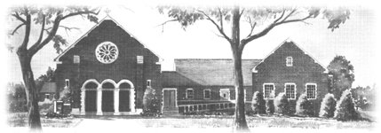

Confirmation Sponsor/Godparent Eligibility Certificate

I, __________________________________________ _______________

will be the Confirmation Sponsor or Godparent (Circle one)

of _________________________________________________________

at _____________________Catholic Church in _____________________.

As a Catholic Godparent or Confirmation Sponsor, I recognize that according to Diocesan regulations and Canon Law, I must meet the following qualifications:

- I must be a practicing Catholic who has received the Sacraments of Baptism, Penance, Eucharist and Confirmation.
- As a practicing Catholic, I must fulfill my obligation to attend weekly Sunday Mass and give a faithful witness to my Catholic faith.
- If I am married, my (present) marriage must be a valid Catholic marriage, witnessed by a Catholic priest.
- I must be at least 16 years old.
- I must not be the mother or father of the candidate.
- I must have every intention of fulfilling my role as Confirmation Sponsor or Godparent by assisting the parents in raising their child as a Catholic Christian.

As the Non-Catholic Godparent / Christian Witness,
- I must be a practicing Baptized Christian.
- I must have every intention of fulfilling my role as Godparent by assisting the parents in raising their child as a Catholic Christian.

In accepting the role as Confirmation Sponsor/Godparent, I hereby affirm that I am committed to helping raise this child as a practicing Roman Catholic and that I meet all of the qualifications listed above.

I am an active registered member of Annunciation Catholic Church in Washington DC.

Signature of Godparent/Sponsor Signature of Pastor

Date Date and Church Seal

